C PROGRAMMING TO CHECK THE GIVEN NUMBER IS PALINDROME OR NOT

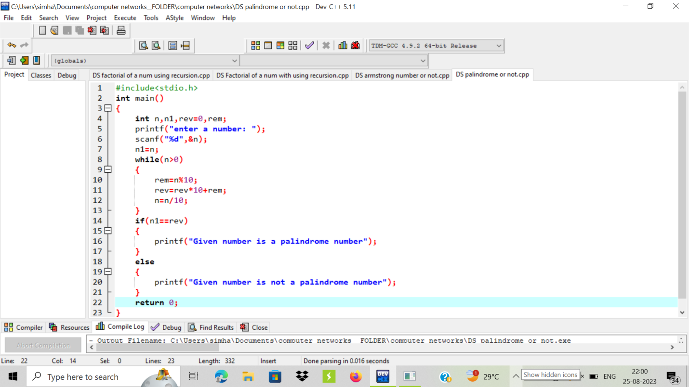

OUTPUT:

